**Regex -REGULAR EXPRESSION SYMBOLS LIST**

**Task 1:**

**RegEX Symbols in linux**

^ caret-- denotes the start of the string

$ dollar sign-- denotes end of the string

. (dot)– check for the single character which is not the end of the line

[] – check for single character in the character specified in []

()- check for string. Create and store variables

? – check for zero or one occurrence of the preceding character

+ - check for one or more occurrence of the preceding character

*-- check for any number of occurrences including zero of the preceding character

| -- Logical OR

\- escaping character- escape for the normal way

! – logical not

{}- repeat preceding character

**Task 2:**

**If you are aware of Linux OS.. can you tell me the feature of Linux.**

Linux is open-source Operating system known for its flexibility, security, and community support.

**Task 3:**

**What is Kernal? can you explain about it in your words..**

Kernel is the critical interface between the hardware and software layers in computer operating system.

**Task 4:**

**BASH in Linux full form and Explanation**

Bourne Again Shell alias BASH

Bash is the command language interpreter for the operating system.It provides users with a simple and efficient way to interact with the system and perform a variety of tasks, such as creating files, editing text, and managing processes.

**Task 5:**

**What do you think is the difference between Linux and Windows?**

Linux is an open-source operating system, meaning its source code is available for anyone to view, modify, and distribute. Windows, on the other hand, is a proprietary, closed-source operating system developed by Microsoft.

**Task 6:**

**What are the basic components of Linux? Describe each in detail with diagrams.**

* **Kernel:**

The kernel is the heart of the operating system. It manages hardware resources, provides services to applications, and acts as a bridge between applications and the hardware. The kernel is responsible for memory management, process management, file system management, and device management.

* **System Libraries:**

System libraries provide a set of functions that applications can use to interact with the kernel. These functions are implemented by the operating system and do not require kernel privileges.

* **Shell:**

The shell is an interface between the user and the kernel. It allows users to input commands and interact with the operating system. There are different types of shells, including command-line shells (like Bash) and graphical shells (like KDE or GNOME).

* **System Utilities:**

System utilities are programs that provide specialized functionalities to users, such as file management, process manipulation, and system administration. These utilities are often used by system administrators and developers.

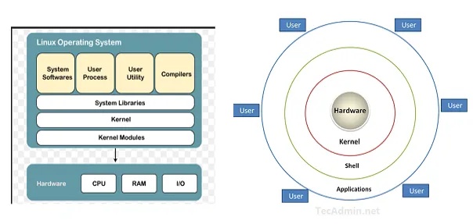

**Task 7:**

**Is it legal to edit Kernel? when do you think we have to in case?**

Yes , it is legal to edit Linux Kernel. Linux is released under the General Public License (GPL) and any project which is released under GPL can be edited & modified by the end users. Editing the Linux kernel can be a daunting task for many, considering its critical role at the core of the operating system. However, understanding how to modify the kernel can provide users with the opportunity to tailor their system to specific needs and optimize performance.

**Task  8:**

**What is LILO? Explain**

LILO (Linux Loader) is a simple and efficient boot loader for Linux-based systems. It was widely used in the early days of Linux to manage the boot process, allowing users to boot Linux or other operating systems installed on the same machine.

**Task 9:**

**What is shell? How many shells are there and what are they ? can you explain.**

|  |  |  |  |
| --- | --- | --- | --- |
| **Shell** | **Complete path-name** | **Prompt for root user** | **Prompt for non root user** |
| Bourne shell (sh) | /bin/sh and /sbin/sh | # | $ |
| GNU Bourne-Again shell (bash) | /bin/bash | bash-VersionNumber# | bash-VersionNumber$ |
| C shell (csh) | /bin/csh | # | % |
| Korn shell (ksh) | /bin/ksh | # | $ |
| Z Shell (zsh) | /bin/zsh | <hostname># | <hostname>% |

**Task 10:**

**What is swap space?**

**Swap space** is a memory virtualization concept that allows Linux to use disk space as an extension of RAM when the physical memory is full. Swap space can also store data from RAM when the system hibernates. There are two forms of swap space in Linux: the **swap partition** and the **swap file**.

**Task 11:**

**What is Mount? how do you mount and unmount file system in Linux?**

* **Mounting:**Mounting is the process of attaching a storage device or partition to a [directory](https://www.geeksforgeeks.org/structures-of-directory-in-operating-system/) or [mount point](https://www.geeksforgeeks.org/mount-command-in-linux-with-examples/) so that its contents can be accessed and managed by computer system users.
* **Unmounting:**Unmounting is the reverse mounting process where the storage device or partition is detached from the computer system. it is making its content no longer accessible until it is mounted again in the computer system.

**Mount:** sudo mount /dev/sdx1 /mnt/mydrive

**Unmount:** sudo unmount /mnt/mydrive

**Task 12:**

**What is chmod command ? how to use it?**

Chmod is used to change access permissions and special mode of flags of files. Abbreviation change mode.

Use: for example if I want to give all permissions like read,write and execute the command will be

Chmod 777 <filename>

**Task 13:**

**Can you add a new user account? Crate a new user in different ways and paste ss**

Sudo adduser <username>

Sudo useradd -m -s /bin/bash username

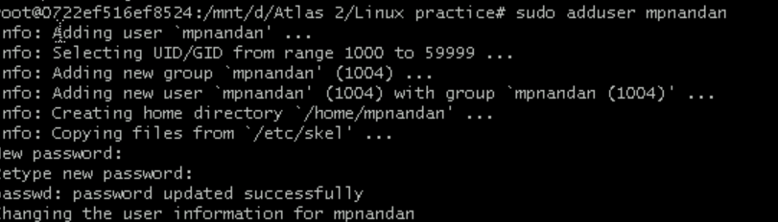

Sudo useradd -m -s /bin/bash username

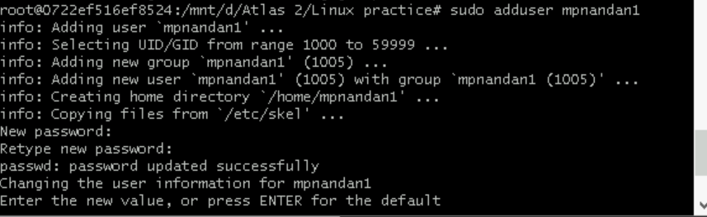

**Task 14:**

**Can you change the password of a user?**

**How do you do that? Plz share ss**

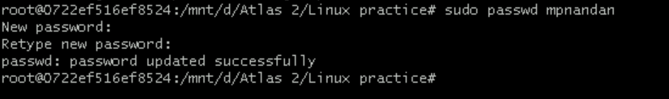

**Task 15:**

**What is diff between Process and Thread?**

|  |  |  |
| --- | --- | --- |
| Feature | Process | Thread |
| Memory | Has separate memory | Shares memory with other threads in the same process |
| Communication | Needs inter-process communication | Uses shared memory |
| Usage | Used for running separate applications | Used for parallel tasks within the same application |

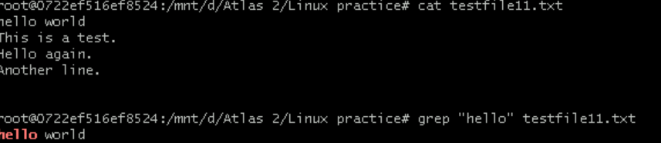

**Task 16:**

**Doc 14 Linux Grep commands in docs to study folder .. plz work on it..**





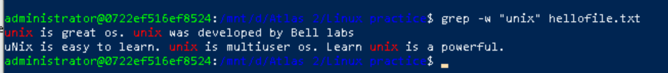

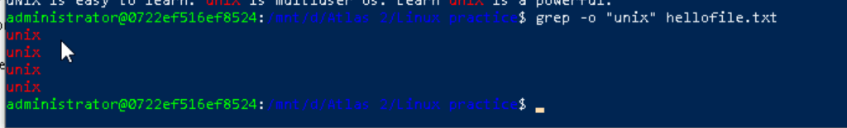



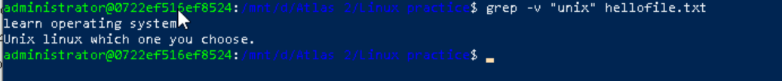



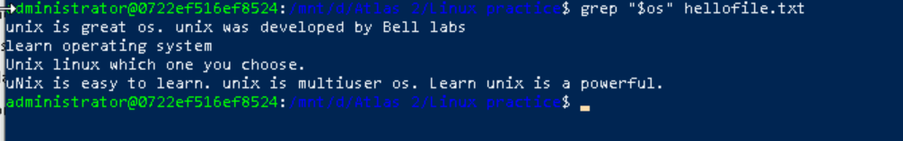

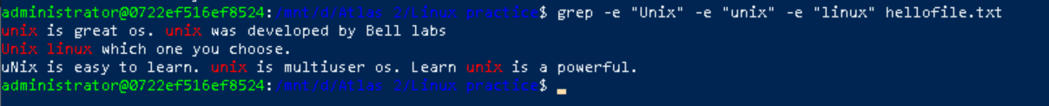

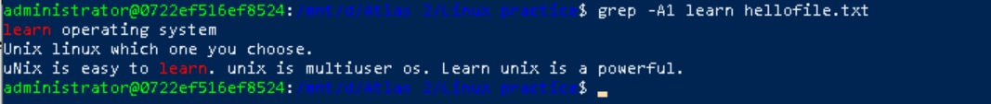

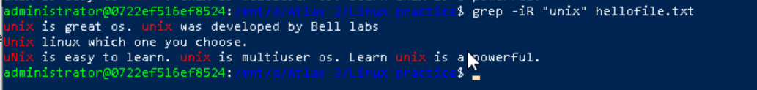

**Task 17:**

**AWK commands in doc 15 Linux AWK commands**.

1.Print entire line

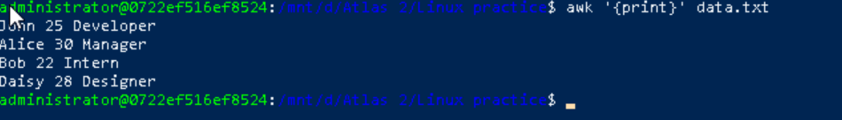

**2. print specific column**

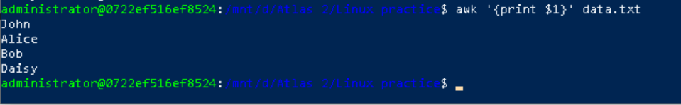

**3. print multiple columns**

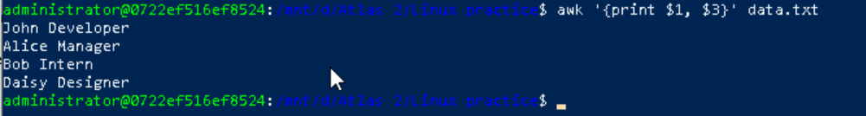

**4. print lines based on condition**

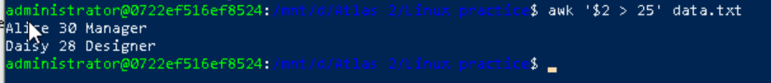

**5.use begin and end blocks**

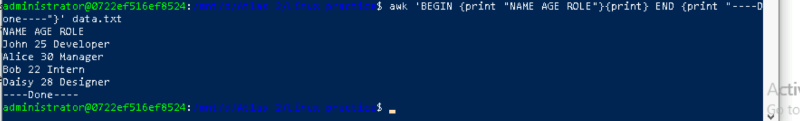

**6. add text or format output**

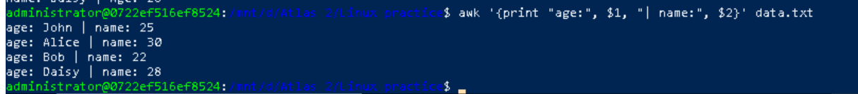

**7. count lines**



**8.sum a column**



**9. average a column**



**10. Use Variable**



**11. match pattern**



**12. extract substring**

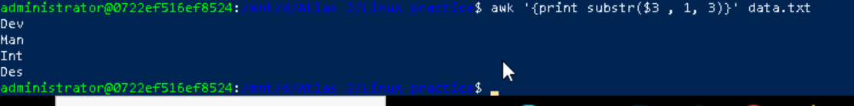

### 13. Example 6: Join Two Files Based on a Common Column



### 14. Example 9: Replace a String in a File



### Example 15: Using Built-in Variables

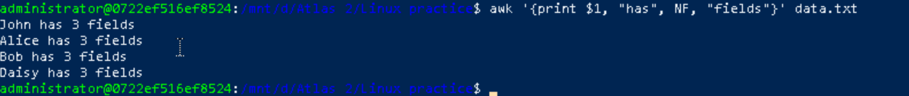

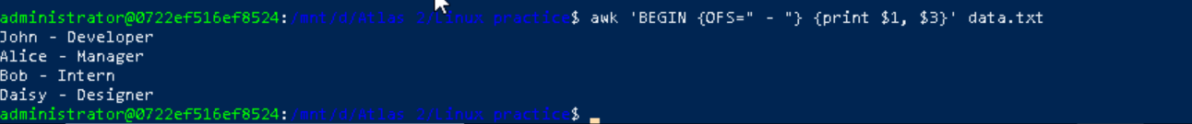



### Example 16: Using Control Statements

### 

**Task 18:**

**How to check file access permission in Linux?**

Using ls -l



**Task 19:**

**What are the default permissions for a new file ?**

Default permission is : rw-r--r--

* **Owner:** rw- (read and write)
* **Group:** r-- (read only)
* **Others:** r-- (read only)

**Task 20:**

* **What is the command to change the permisssion to read only for the owner, group and all other users**

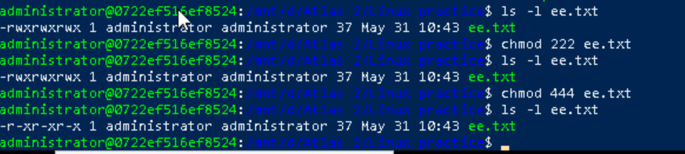

Task 21:

Can you change the file permissions to match the following:

* owner: Read and Write
* group: Read
* other: no permissions (None)

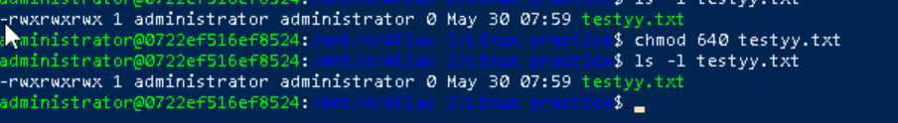

Task 22:

What was the command for changing the file permissions to -rw-r-----?

Hint : use chmod 640 filename

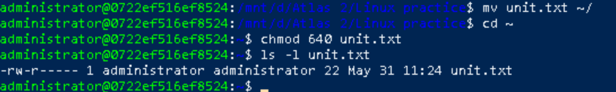

Task 23:

Change chmod.exercises permissions to -rwxr-x--x

Change the file permissions to match the following:

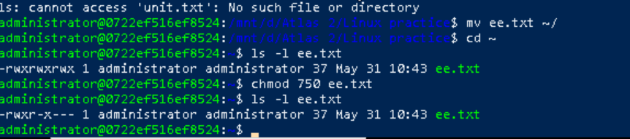

Task 24:

What was the command for changing the file permissions to -rwxr-x--x

Hint : use chmod 751 filename

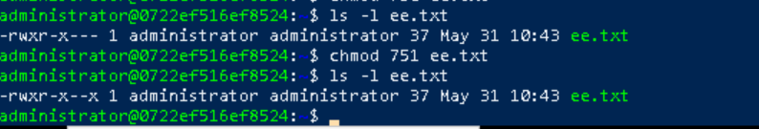

**Task 25: Guys what will this command do?(** chown -c master file1.txt)

Answer--- used to change the owner of the specific file

**Task 26: Can you define what is  a processes?**

A processes is a running instance of a program. Linux treats everything as a process from your shell terminal to system services. Each process has a process id (PID) a unique number assigned by the OS

**Task 27:**

**What is command to check foreground process and background process**

Answer : ps

**Task 28: Can you list all the running processes?**

**Hint use ps**

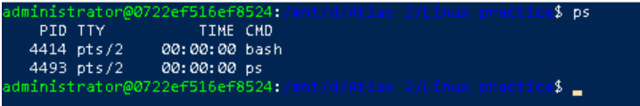

**Task 29:**

**What will ps -f command do ? plz try n check .. ss required.**

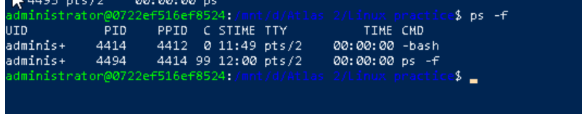

**Task 30: Can you create  a variable name with your name in it ?**

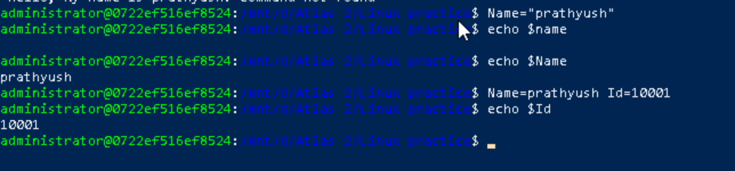

**Task 31: Can you make the above name variable read only..**

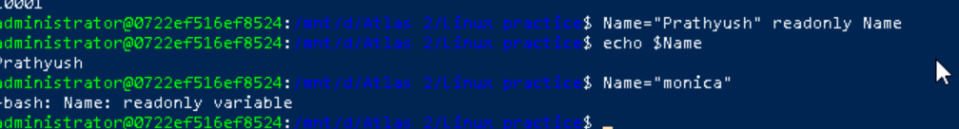

**Task 32: Now will unset or delete the variables**

Tried to unset in same session , it wont work as it is read only . for that we need to close the current session and open a new session .

**Task 33:**

**Can u try to add a list of your friends names in an array and try to printout?**

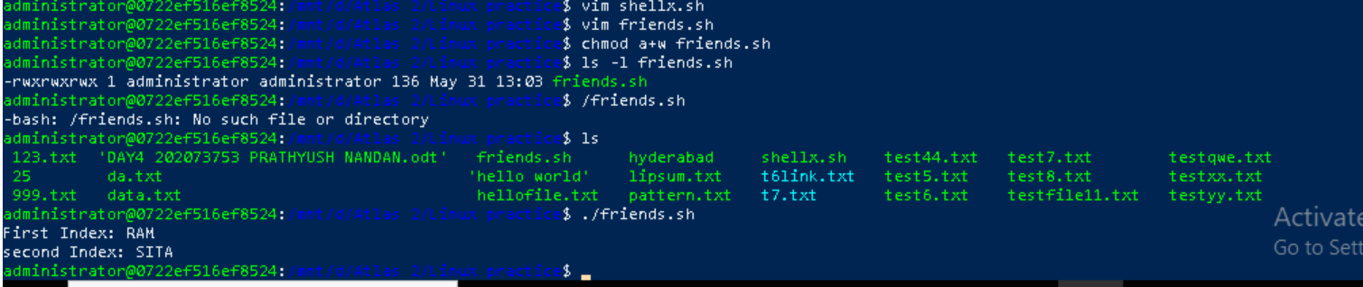

**Task 34:**

**Can you print all the list at once in an array.. Try the below cmds and check**

**Echo “${array_name[*]}”**

**Echo “${array_name[@]}”**

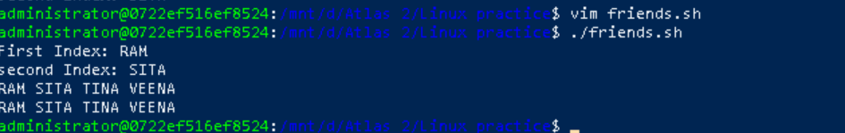

**Task 35:**

Plz let me know whats the output of the below snippet:

a=0

while [ "$a" -lt 10 ]    # this is loop1

do

   b="$a"

   while [ "$b" -ge 0 ]  # this is loop2

   do

      echo -n "$b "

      b=`expr $b - 1`

   done

   echo

   a=`expr $a + 1`

Done

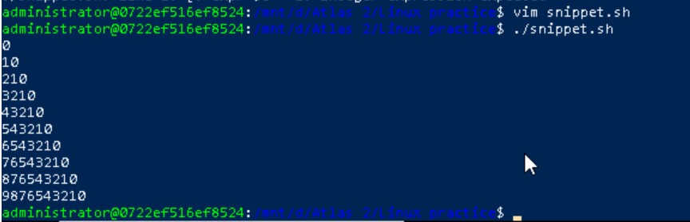

Symbolic link

